Preface by Karl Eggert to El Maestro

LIBRO DE MUSICA DE VIHUELA DE MANO
INTITULADO EL MAESTRO
COMPUESTO POR
LUYS MILAN
Valencia 1535/1536

The tablatures were written by Jason Kortis and revised and supplemented with most of Milan´s notes and two informative prefaces by Karl L. Eggert (2008).

The work is based on the Edition of Leo Schrade (Reprint and Transscription):

LIBRO DE MUSICA DE VIHUELA…LUYS MILAN
Breitkopf und Haertel in Leipzig 1927
Photoreprint 1994 by
Georg Olms Verlag, Hildesheim - Zuerich – New York
Breitkopf & Haertel , Wiesbaden

Parts of this tablature series (every part one file):

I Fantasies 1-9 with preface
II Fantasies 10-22
III Fantasies 23-33
IV Fantasies 34-40
V Pavans 1-6, Tentos 1-4 with preface about pavans and tentos

For information about El Maestro and some musical items such as modes,
compas, and tempo see the preface of part I, following below.
For information about pavans and tentos, see the preface of part V.
Preface of part I

Contents of El Maestro
Musical items:
1. Notation
2. Notes to the peces
3. Compas and time signatures
4. Milan and the modes
Problems with midi playing

Contents of El Maestro

Milan´s El Maestro is divided into two books.

The first book
is made to teach playing the vihuela from the beginning. It contains eight parts quadernos=booklets, a printing section each):

- About the right understanding and use of the book (quaderno 1)
- Fantasias 1-9 (quadernos 2+3)
easy music in different modi, apt for a beginner´s hands
- Fantasias 10-18 (quadernos 4+5)
music with different runs (redobles), to make “dedillo”[playing by shaking the index
like a plectrum] and “dos dedos” [alternating index and middle finger or thumb and
index]. This music is more concerned with gala performance than with music or time
measure.
- Fantasias 19-22, Pavanas 1-6 (quadernos 6+7)
music which is somewhat more difficult and requires a better hand, with some runs.
- music to sing songs (quaderno 8)
villancicos in Spanish and Portuguese, romances, and sonetos in Italian

The second book
contains more difficult music, i.e.

- Fantasies 23-33
“In this second book you will find the modes in other tones (transposed) on the vihuela
than in the first book.”
- Tentos 1-4 (Fantasias de tento = trial fantasies)
Noteto the 1st tento: “Its manner is, to try the vihuela with chords mixed with runs.”
The four fantasias de tento pass through all eight modes.
- Fantasies 34-40
- Villancicos in Spanish and Portuguese, and sonnets in Italian
- Right understanding and declaration of the modes,
which are used in figural music.

Here we deal only with music for vihuela solo, not with the songs.
Musical Items

Milan says in his Declaracion del libro:
“Therefor it is very necessary for one who wants to know playing the vihuela by (the help of ) this book, that he learn at first the figured music (canto de organo), until he singing knows to understand how to keep tempo and rhythm (traer el compas y mesura).”
Milan assumes, that a reader, which is prepared this way, will know about modes, compas, and mensural notation. For some of us, these items are more or less unknown. “Therefor it is very necessary” to give some explanations.

1. Notation

Milan used what we call Spanish tablature, whereas other vihuelists used Italian tablature. The tablature has the bass string on the deepest line, the frets are given by numbers. The highest used fret is the tenth with symbol X. As rhythm signs he used mensural notes instead of the flags used in most lute tablatures.
On the following facsimile from El Maestro (Pavan 6), in original ca 16x22 cm, the notes can be seen above the tablature. At the end of every piece, a long is printed as a closing sign. In fact, the last note should have a shorter time length than a long (which normally equals two breves). As there is no longa sign available in fronimo, I always set a breve as last note.

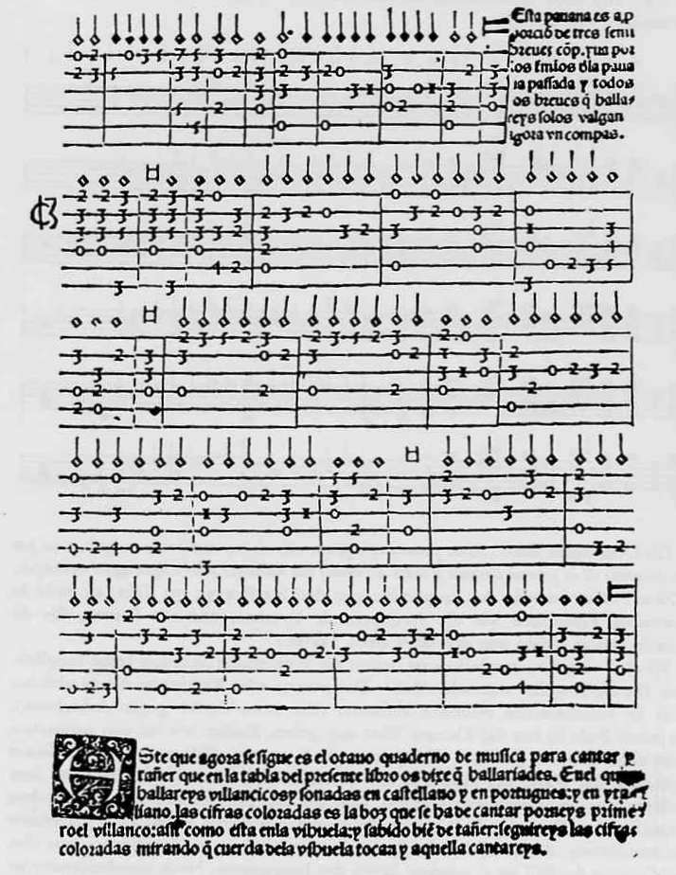

The mensural notes are similar to our modern notes, but during 500 years their values have changed.
Their time length has doubled, roughly said. So the semibreve, which has developed to our whole
note, is equivalent to the modern half note.

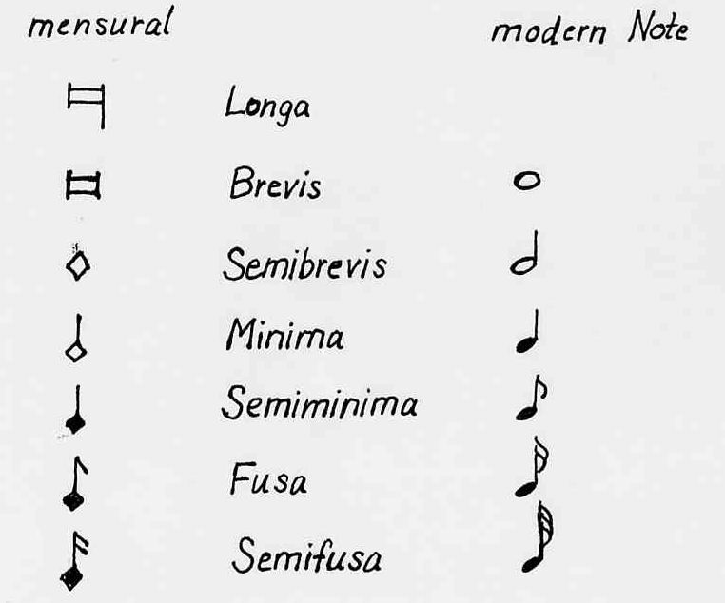

The relations between the values of the the breve and the semibreve, and the semibreve with the minim were in the mensural system not always 2:1, but could be 3:1 in the perfect mensural signa-tures. We see this in triple time mensural signatures, where a breve alone in a bar has the value of three semibreves (see below).

2. Notes to the pieces

Milan wrote for every piece a short note, where he gave information about the mode, the tempo (compas), and sometimes other issues. As these informations are useful for understanding the pieces, I added the important part of every note to the tablature, sometimes with the Spanish text.

3. Compas and time signatures

Compas
is a time measure given by rising and lowering hand or foot in an even speed, invented to keep a choir in the right tempo. The time length of a compas is that of one rise plus one lowering.
In Milan´s book a bar has always the time length of a compas. Milan uses two kinds of compas:

1. compassillo, this is the normally used compas.
It has the time value of a semibrevis. That means: one bar has the value of a semibreve.
2. compas mayor, which has a breve value.
It is used to write music in long note values, that then can be played shorter – especially apt for music with fast passages. Milan uses it only in fantasia 33.

Compas is equivalent to the tactus (tactus minor/integer, tactus maior) used in other countries and described by such writers as Gafori or Agricola.

Compas and Tempo

Milan gives for nearly every piece a direction concerning the tempo or time measure to play with. He orders the time length of the compas (bar) to be
short (con el compas apriessa= quick)
(con el compas apressurado=hurried)
(con el compas algun tanto apressurado=rather hurried)
(con el compas algo apressurado= somewhat hurried)
intermediate (ni muy apriessa ni muy a espacio sino con vn compas bien mesurado
= neither very quick nor very slow but rather moderate)
or long (con el compas espacio= at leisure, slow).

In the “fantasias de consonancias y redobles” (e.g. nos 10-18) and in the tentos where consonances (chordal or contrapuntal passages) alternate with fast passages, the compas shall vary within the piece: chords have to be played slowly, runs fast. The performance of this music shall be impressive(gala playing) rather than rhythmical precise:

“…a kind of music which is more concerned with gala playing rather than keeping time mea-sure.(…vna arte de musica que tiene mas respecto a taner de gala que no a seruar compas)”.
(Note at the end of libro I)

The compas mayor with a breve value (breve bar) appears as basic mensural signature for pavan 6
and fantasia 33, and with signature proportio tripla (see below) as part of a number of fantasies.
It is used with large note values, which have to be played shorter than in C cut. The pulse is here given by the semibreves, instead of the minims (range about 100 semibreves per minute).

We do not know exactly, what time length a semibreve compas should have. A semibreve tactus (equivalent of compas) probably lasted about 1/60-1/70 minute, like the human pulse (1/65→130
minims per minute), but it could be varied in length, as Milan did.

I suggest for the fantasias in duple time
for compas espacio down to 7o minims per minute
compas bien mesurado (moderate) about 100
compas apriessa or apressurado 120 up to 140
For the pavans (con el compas algo apressurado) I would take 110-120 minims per minute.

Mensural time signatures

were developped in the middle ages and used till after the end of renaissance, especially for clerical music. Among other information, they give relations between the tempi in which the various time measures have to be sung or played. Milan uses the following mensural signs, usually printed among the notes above the tablature lines (exception: pavan 6 where it stands at the beginning of the tablature, see facsimile above).

Proportio tripla (proporcio de tres semibreves compas)
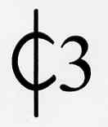This time signature is tempus imperfectum cum proportione tripla, also called proportio tripla normally written with the sign C3 after it. Milan uses the sign C cut with a 3 after it, which was used in the same meaning. This time measure was used for triple time or to figure triplets in duple time.
The bar length is that of the compas mayor, i. e. a breve. As we have a time measure with perfection, the breve value of a bar equals three semibreves instead of two.
The proportio tripla assigns, that three semibreves now shall be played in the time that one semi-breve takes in normal duple time. So the time length of this breve bar becomes equal to a normal semibreve bar. This gives a tempo increase of the semibreves 1:3, compared with normal duple time [e.g. C cut].
Milan uses the proportio tripla as a basic time signature only for pavan 6. Here it is comparable with a modern 6/4-time, every two bars forming a measure.
More often it is used in fantasias for a change to triple time. Here the preceding time measure is always duple time with a semibreve bar. So the time length of a bar remains unchanged by propor-tio tripla. Yet the tempo of the semibreves and minims increases 1:3.

So far the theory. In fact this tempo increase from duple time to proportio tripla seems too large
for some pieces. Especially those with fast basic compas (e.g. fantasies 31, 36, 40) and with semi-
minims in the triple part get too fast there. The pieces sound in parts hasty and are hardly playable.
On the other hand, if the triple part were played in an appropriate slower tempo, the duple part would become too slow.

It is possible, that Milan used the proportio sign merely to assign triple rhythm, leaving the tempo change to the taste of the player. We can see a similar inaccuracy in other lute tablatures, cf. Dalza 1508, Recercar f.7 or Attaingnant 1530, Gaillards of P.B. with subiectum in proportio tripla.

If the 1:3 tempo increase seems too large, a quite natural tempo change can be achieved by keeping the pulse of the duple minims for the triple semibreves. So we get a tempo increase of 1:2, instead of 1:3.

In the proportio tripla, breves alone in a bar have no dot. This is correct, because they are “perfect”, i.e. they have the value of three semibreves instead of two (three is the holy number of perfection).

Prolatio maior for triple time, dotted minims
This mensural time signature is tempus imperfectum cum prolatione maior, also called prolatio maior. Three minims shall now be played in the time of two before, like triplets.
Milan uses this mensural signature for triple time with dotted minims. It is comparable with a modern 6/8-time, two bars forming a measure.
A bar has now the time length of three minims or a (perfect) semibreve. As the preceding time mea-sure (C cut) also has a semibreve compas, the time length of a bar remains unchanged. Yet the tempo of the minims changes 2:3 (like triplets).

Semibreves that stand alone in a bar have no dot, because they are “perfect”, that means they equal three minims instead of two (three is the holy number of perfection).

“Cut C” for duple times, slow or fast
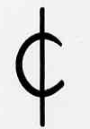This is the time signature tempus imperfectum diminutum, prolatio minor, also called C cut, which was generally used for duple or quadruple time in the sixteenth century. Milan uses it with the semibreve compas, i.e. one bar has the value of a semibreve.
The signature is used by him only when to return from triple to duple rhythm. It could have been set at the beginning of the duple time pieces as well, but Milan didn´t do.
As the preceding triple compas in the fantasias always has a (normal) semibreve time length, the time length of a bar remains unchanged by the new signature. Yet the tempo of the minims is redu-ced to get the basic duple tempo again:
After prolatio maior, the tempo of the minims is reduced 3:2.
After proportio tripla two minims now last as long as three semibreves before.

4. Milan and the modes (los tonos)

Milan´s music is written in scales named (clerical) modes. Some of them were already used in ancient Greece, but the renaissance system of modes was created in the middle ages as base for the clerical vocal music.
At Milan´s time, there were eight modes. Our modern sharp and flat scales were also in use, but not yet scholarly accepted as modes. Milan uses only the classical eight modes.

Definition

All eight modes (if untransposed) use the same tones for their scales: c-d-e-f-g-a-b, yet they sound different, as the semitones in the scales are at different positions.
Please note: Milan´s nominal vihuela tuning is not in G, but in A (A-d-g-b-e´-a´)!

authentic modes (tonos maestras):

name scale finalis ambitus
dorian d-e-f-g-a-b-c-d d c-e´
phrygian e-f-g-a-b-c-d-e e d-f´
lydian f-g-a-b-c-d-e-f f e-g´
mixolydian g-a-b-c-d-e-f-g g f-a´

and the corresponding plagal modes (tonos discipulos, presyllable “hypo”):

name scale finalis ambitus
hypodorian a-b-c-d-e-f-g-a d G-b
hypophrygian b-c-d-e-f-g-a-b e A-c´
hypolydian c-d-e-f-g-a-b-c f b-d´
hypomixolydian d-e-f-g-a-b-c-d g c-e´

Finalis
is the tone on which a modal piece ends. Authentic and corresponding plagal scale have the same finalis but start on different tones. The authentic scale starts with the finalis, the plagal scale a fourth below.

Ambitus (in Spanish los terminos)
is the tone range a mode can use. Milan explains, that every mode has an ambitus of ten notes. (The usual definition of ambitus encompasses nine notes.) The authentic ambitus reaches from the finalis nine [correct: eight!] notes up and one note downwards. The plagal ambitus reaches from a fourth below the finalis nine [correct: eight!] notes up and one note downwards.
E.g. for the dorian mode: finalis d, ambitus c-e´; for the hypodorian mode: base tone a fourth below d (=A), ambitus G-b.

Mixed modes (tonos mixtos)
There is a lot of fantasies in El Maestro, that are in a mixed mode. A piece is composed in a mixed mode, if its soprano voice uses not only the authentic ambitus (nine steps up, one down below the finalis), but goes three or four steps below the finalis. So it uses the ambitus of the authentic mode, and also that of the corresponding plagal mode.

Transposed modes (tonos por otra parte)
The transposed modes use scales with the same intervals between their grades as those nontrans-posed, but start at another base tone. Most often the transposed scale is a fourth higher (or a fifth deeper); then it has a b as clef alteration.
The transposition served to improve the playability of a piece or to use a special timbre of the instrument. So some modes were usually played in a special tranposition on the vihuela:
“And because the fifth and sixth mode are used more playing in the [transposed] note range of this fantasia…” (note to fantasia 16)

In the second book, Milan presents fantasias in the same eight modes as in the first book, but now mostly transposed. Note to fantasia 23:
“The following fantasy is in the first mode, transposed to another part of the vihuela (por otra parte) than I have shown you in the first book. And so you will find the modes in this second book on other parts of the vihuela than in the first book….”

Transpositions are very often made a fourth upwards, except of the 3rd and 4th mode, which is mostly transposed to g.

Closes (clausulas) and cadences (cadencias)

Closes and cadences were used in renaissance to give a piece structure and expression, similar to using commata and fullstops in writing. It is therefor good to recognize closes and cadences and make them audible by appropriate playing.
Every piece ends with a final close or a final cadence, which gives an impression of closing to the hearer. In fact, nearly all pieces in El Maestro end with a cadential chord, and not with a close.

A close
is a formula-like sequence of two or more notes in a voice which leads to a resting or final point. Another kind of close is a sequence of two intervals, often formed by the cantus and tenor voices, which goes from an imperfect consonance (third, sixth) to a perfect consonance (unison, octave, fifth) and thus produces an impression of closing or resting.
The final close of a piece ends on an octave or unison of the finalis of the mode.

A cadence
is a sequence of two or more chords that creates the impression of closing (especially the final cadence) or having a resting point. A final cadence usually has a closing character. It ends then on a chord on the finalis, usually containing its (major) third, fifth, and octave (third or fifth or octave can be missing).
There are also final cadences which have not a real closing character, e.g. plagal cadences or a cadence with a chords on the finalis and then on the dominant. These do not end on the finalis and thus cannot be used to recognize it.

Milan the gives the scale grades of a mode on which closes [and cadences] shall be made:
on the first, fifth, eighth, and the fourth grade of the scale,
also on the third “if you like”.
[This is not valid for all modes, especially the 3rd and 4th mode]

Example: For the dorian mode closes are made on d, a, g, d´, (f)
For the hypodorian mode: a, e, d, a´, (c)

How to identify the mode of a piece

As Milan gives in his notes to the pieces always the mode of it, we don´t need to identify any mode. Nevertheless, Milan in most cases doesn´t say if the mode is transposed, and to what finalis it is transposed. How can we find out the mode of a piece?

Milan declares: a mode can be identified
1. by the tone range of the soprano voice (cantus),
2. by its closes [cadences] (see above),
3. by its finalis, which can be recognized by the final close or chord (see above).

First, look at the last chord of the piece which is usually on the finalis. Pieces can also end on the fifth or fourth or sixth above the finalis, but not in El Maestro.
Example: last chord is on d → finalis d → dorian or hypodorian
Second, compare the note range with the ambitus of the two modes. It must fit at least one of them. Example: tone range B – d´
Dorian ambitus: c - e´, hypodorian ambitus G - b → mixed mode dorian/hypodorian

If the finalis is none of the standard ones (d, e, f, g), we must have a transposed mode.
In this case we must find out the scale grades of the mode and compare the scale structure with that of the untransposed modes. The wanted mode has the same scale structure as our transposed scale. A mode with a finalis d, e, f, g can also be transposed (e.g. phrygian mode transposed to g).

Problems with midi playing of Fronimo sections

A) The midi program does not understand the meaning of the mensural time signatures, and thus simply ignores them. So the pieces with a change of time signature are not played correctly.

If a piece goes from duple time to proportio tripla, it cannot be played there in the correct increased tempo. The breves are in the proportio tripla as slow as in normal duple time. Similarly the speed of the minims in prolatio maior is not adjusted.
The perfect breves which equal three semibreves (e.g. in pavan 6, at the end of fantasia 31), sound for the time of only two, because they have no dot, similarly the perfect semibreves in prolatio maior (fantasy 15).

The correct tempo cannot be achieved by simply setting a normal triple time signature and reducing the note values in proportio tripla and,or giving the perfect breves a dot. We rather would need the possiblity of well defined tempo changes in the piece by the midi program.

B) Another problem is, that the midi playing of some files does not work as it should.

In fantasy 32, the speed is halved from bar 5 on. In fantasy 30, the speed suddenly goes up at bar 71.
After the prolatio sign in bar 76, the tempo gets slow again. With the C cut sign in bar 106, the tempo becomes very slow and stays so for the rest of the piece. This tempo cannot be changed. In fantasy 19, the tempo becomes slower with the prolatio in bar 59 and cannot be controlled from bar 108 on.
In some files, the speed cannot be changed after a mensural time signature, e.g. fantasy 35 after bar 112, fantasy 30 after bar 76, fantasy 19 after bar 108.
These problems seem to have to do with the use of mensural time signatures, but they do not occur generally with the signatures.

I hope you will enjoy the music on the lute or vihuela, if midi does´nt work.

Karl L. Eggert

